N.sri vara deepak
192572075
Experiment-9
Title
Travelling Salesman Problem using Python
Aim
To find the shortest possible route that visits every city exactly once and returns to the starting city.
Algorithm
- Define the distance matrix.
- Generate all possible routes.
- Calculate the total distance of each route.
- Select the route with the minimum distance.
- Display the shortest route and its cost.
Program
from itertools import permutations

graph = [
[0, 10, 15, 20],
[10, 0, 35, 25],
[15, 35, 0, 30],
[20, 25, 30, 0]
]

cities = [1, 2, 3]

min_cost = float('inf')
best_route = None

print("All Possible Routes:\n")

for route in permutations(cities):

full_route = (0,) + route + (0)

cost = 0

for i in range(len(full_route) - 1):
cost += graph[full_route[i]][full_route[i + 1]]

print(full_route, "Cost =", cost)

if cost < min_cost:
min_cost = cost
best_route = full_route

print("\nBest Route:", best_route)
print("Minimum Cost:", min_cost)
Output
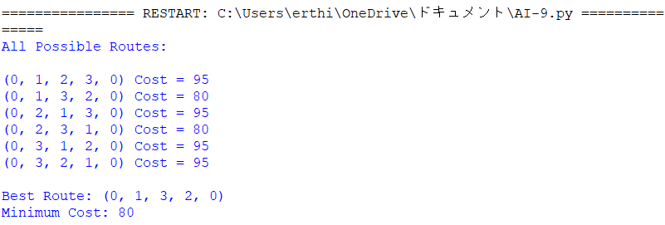
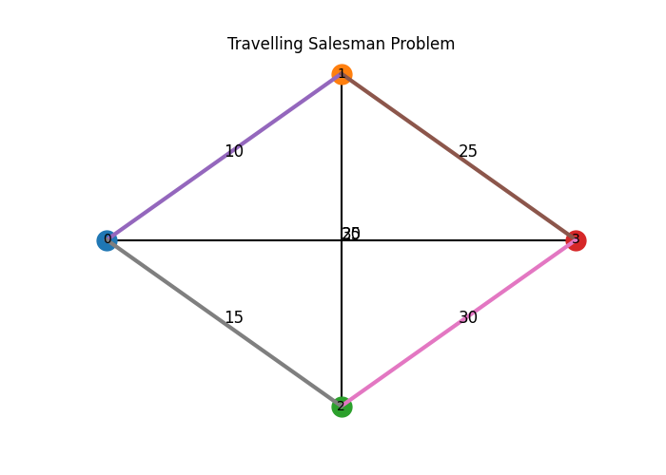
Result
The shortest route and minimum travel cost were obtained successfully.

